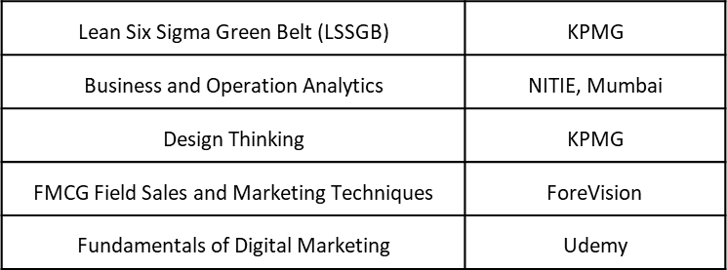

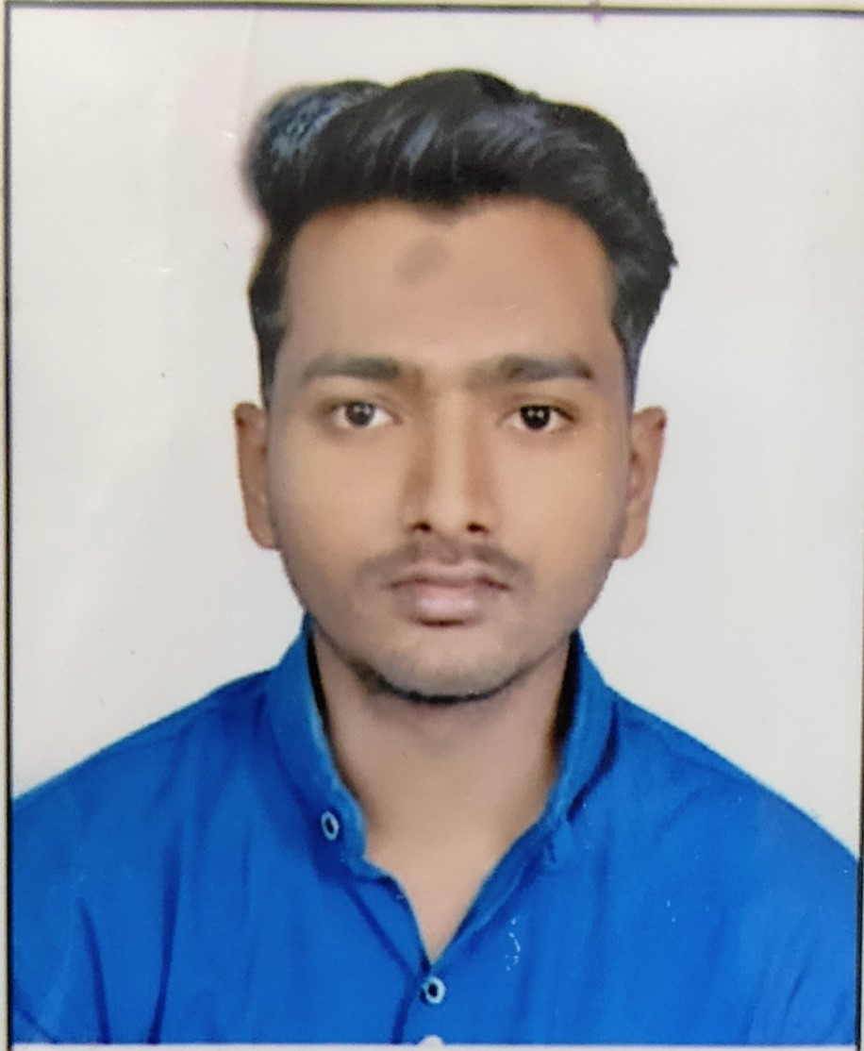

Harshvardhan Kalbande

Analyst A4

 SUMMARY

I am well-versed in technology and writing code to create systems that are reliable and user-friendly. also done several certifications to enhance my knowledge in the field. skilled leader who proven ability to motivate, educate and manage a team of professionals to build software programs and effectively track . confident communicator and innovative creator to develop software that is customized to meet a company’s organizational needs

 KEY SKILLS

• Coding Language (C , JAVA)

• MYSQL

• Data Analysis

• MS Powerpoint Presentation

+91 9518331040

harshvardhan.kalbande@capgemini.com

# EXPERIENCE

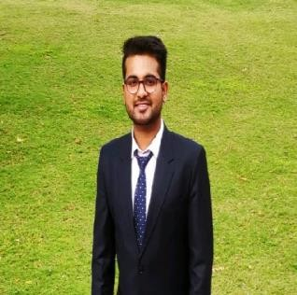

Shriyanshu Khare

NA Apps Consultant

## SUMMARY

I am detail-oriented, well-organized and MBA graduate from IIFT with a passion for marketing and supply chain management. I’ve done several certifications to improve my marketing and

operations skills and abilities. I’ve also done various internships in the same areas to exhibit my interests and knowledge, and they've definitely contributed value to my talent and enriched my learnings and competence in the same.

## KEY SKILLS

* Go-To-Market Strategy
* Market research and Strategy
* Business development and Sales
* MS Excel
* Power Point Presentation

7987978968

[shriyanshu.khare@capgemini.com](mailto:shriyanshu.khare@capgemini.com)

**Analyst A4/Software Engineer**

*(Apr 2022 - Present)*

**CAPGEMINI** – Mumbai

**Software Engineer Trainee**

*(Mar 2021 – Jun 2021)*

**Academic Project II– Nutrifit App**

* + - * It is a food planning mobile application based on android platform.
      * In this object project I have used java language

**Software Engineer trainee**

*(July 2020 – Sep 2020)*

**Academic Project I- Agromart Web Application**

* + - * Worked as web developer, involved to create a online market for farmers to sell their products at better rate.

 _____________________

Extra-Curricular Activities

* Key core member of college student council.
* Core member of event management in college.
* Participated in inter-college cricket team.
* I worked with jeevnandini foundation working for conservation of rivers in city and across india.

# EDUCATION

**B.TECH**

*(2017-2021)*

**MGMs COLLEEGE OF ENGINEERING,NANDED**

Specialization – Computer Science and Engineering

**HSC**

*(2016-2017)*

**N.E.S. SCIENCE COLLEGE , NANDED**

Specialization- PCM

• Agile Software Development Course - Coursera

• The Complete Java online Foundation course GeeksforGeeks

• Channel Management and retailing - Coursera

CERTIFICATIONS